FROM : STEPHANOS CHILDREN HOME, INDIA
NAME : Seigouhao Hangshing
DATE OF BIRTH/AGE : 11th March 2011
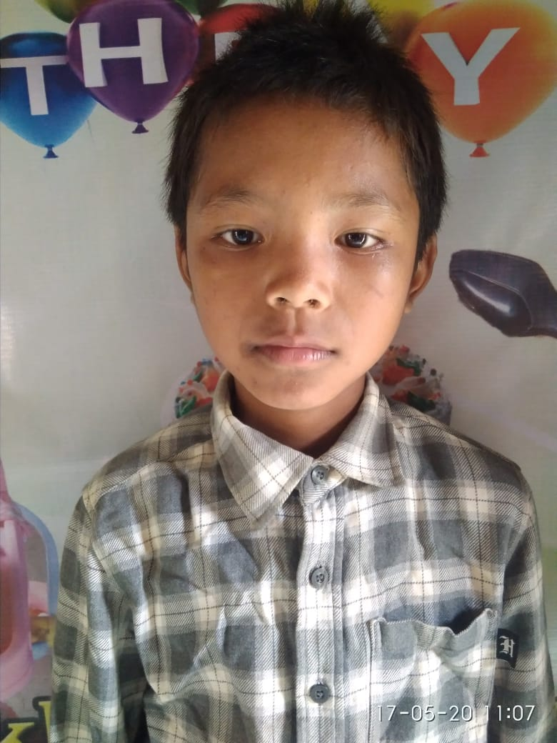
Seigouhao Hangshing hails from a village called H. Khopibung in Manipur, India. He is a very creative kid. Tragically, his father passed away owing to his bad health in the year 2004. Thereafter, his single mother could hardly afford to keep bread on the table as she has no other source of income rather than earning small and irregular daily wages depending on the availability of daily works. His mother had tried her best to send all her kids to school but all she had saved were only enough to provide for their food. Wanting a good future for her kid, he was brought to Stephanos home in Feb, 2020 where he his education, food, shelther and spiritual guidance are met. His hobby is playing Football.

