FROM: BLUE HAVEN LUCKNOW, INDIA
NAME: Tsewang nurboo
DATE OF BIRTH: 10/06/1999
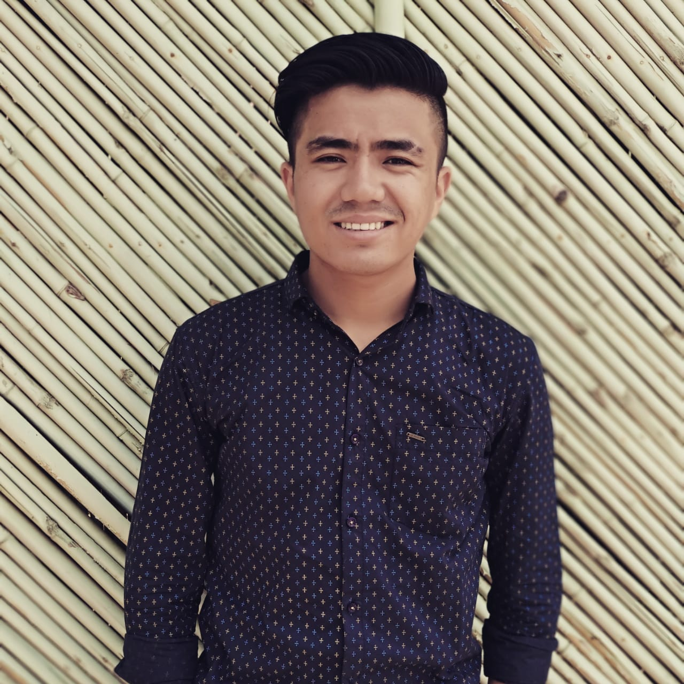

Tsewang is from Leh Ladakh. He has one elder brother and he is the Youngest of the family.
His mother is a house wife and she works in the farm to earn for daily living.
He was brought to Blue Haven in 2005 because his family had a financial problem and they could not afford to pay for his education since his mother could barely support them with the income she got through the farm.
Currently he is doing BBA (Bachelor of Business Administration)
He wants to work as a Company Secretary after he graduate. He needs your love and support.
His prayer is that God will send someone who will be able to help for his education so that he can pursue his ambition and help others after he has a Job and do social work.
To pursue his BBA, he needs Rs. 40,000. His hobbies are playing drum, guitar and learning new things.

