FROM: BLUE HAVEN HOME, LUCKNOW, INDIA
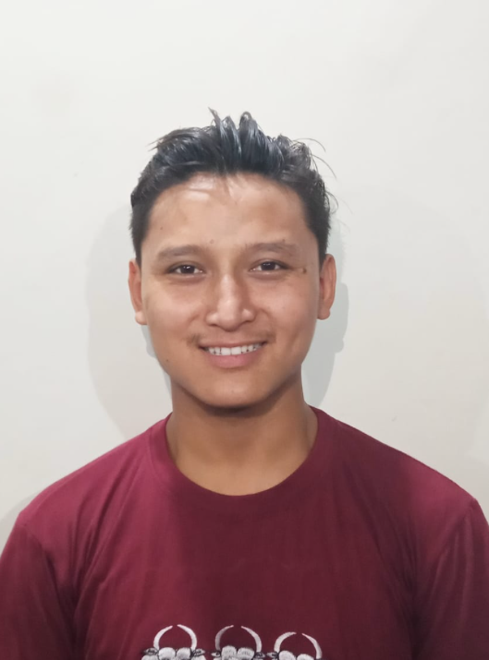
N AME: NURBOO

This is Nurboo from Blue Haven Children's Home, Lucknow India. He wants to pursue Nursing school and he needs your help, prayers, and support.
He needs help with paying for his Nursing School fees which costs $980 for the first year. We pray the Lord will use you to help with this need so that Nurboo can continue his studies in the hope of a brighter future.
If the Lord is leading you to help with this need then, please listen to the Lord's call by giving.

Thank you & God bless!

