FROM: RAINBOW HOUSE, NEPAL
NAME: KANCHI MAYA
DATE OF BIRTH: FEB 8, 2001
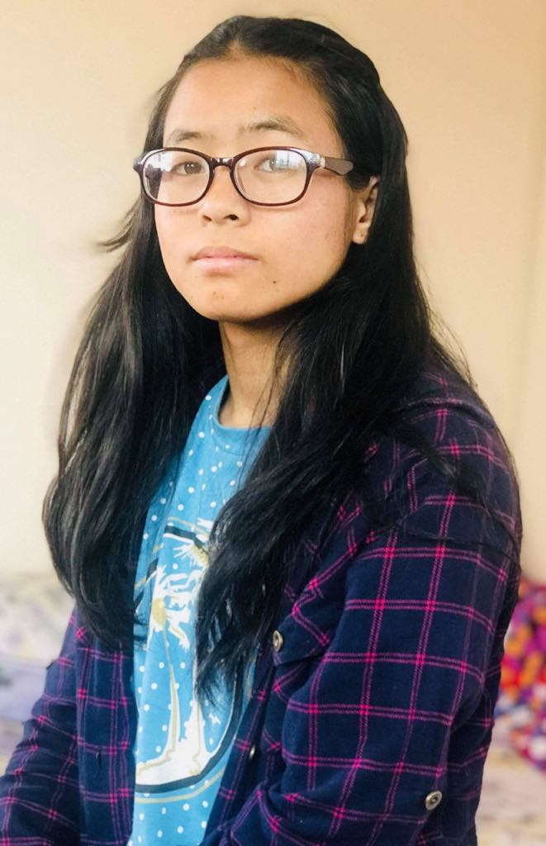

Kanchi Maya Sherpa is from solu district. She lost her mother when she was very small. Her father married to another woman. From that day, she has been brought to Rainbow House. She just finished her 10th Slc and is waiting for her result. She needs your help as she wants to become a Nurse.

